Appendix A

Lancashire: Integral to the Northern Powerhouse

The Lancashire Strategic Transport Prospectus:

Lancashire as part of an Interconnected North

Foreword

Chair of Transport for Lancashire/ Chair of Lancashire Enterprise Partnership

Executive Summary

The Purpose of this Prospectus

Lancashire is a key economic sub region within the North West and the wider North of England. It has a fundamental offer to make and role to play within the developing Northern Powerhouse. Lancashire's leading national and regional position in relation to Aerospace, Advanced Engineering and Manufacturing, Energy and Higher Education Institution excellence make it a pivotal part of the long term sustainability of the North's economy, as does its internationally recognised visitor offer.

As elsewhere within the Northern Powerhouse, connectivity is fundamental to maximising this growth potential. Those transformational and supporting transport interventions that underpin strategic economic growth in Lancashire and the wider North need to be prioritised and delivered as part of an integrated approach.

The purpose of this strategic transport prospectus is:

- To articulate Lancashire's key economic growth priorities and in particular, those that play a critical role within the Northern Powerhouse;

- To demonstrate the rationale for developing a transport system to support Lancashire's economic growth and that of the Northern Powerhouse;

- To present the transformational transport priorities for Lancashire; and

- To set out the mechanisms and timescales for delivery.

An Interconnected North

In June 2014, the Chancellor of the Exchequer set out his vision for a 'Northern Powerhouse', a collection of northern cities sufficiently close to each other that, when combined economically would be able to challenge the World and in so doing, contribute to rebalancing the UK's economy. The Chancellor considers transport to be key to achieving this vision, together with science and innovation, culture and the environment and governance. However, in his view, the transport network in the North is simply not fit for purpose and certainly not good enough to enable cities to pool their strengths. The Chancellor therefore identified the need for an ambitious plan to make the cities and towns across the North much better connected to create the equivalent of travelling around a single global city.

In March 2015, HM Government and Transport for the North published a report on the Northern Transport Strategy, "The Northern Powerhouse: One Agenda, One Economy, One North." The report sets out how transport is fundamental to achieving the shared vision of transforming growth in the North of England, rebalancing the country's economy and establishing the North as a global economic powerhouse. This will require the development of a world class transport system to better link up the individual cities and towns across the North to allow them to function as a single economy and hence be stronger than the sum of their parts.

The Northern Transport Strategy builds on the analysis and conclusions of HS2 Ltd, the One North Proposition for an Interconnected North and the Transport for the North Partnership Board, all of which reaffirm the strategic case for the Phase 2 extension of HS2 to both Manchester and Leeds. It seeks to address not just the issue of capacity in the North but the greater problem of connectivity. The proposition is therefore to integrate HS2 into a wider strategic transport network across the North to fundamentally transform connectivity and in so doing, spread the economic benefits of HS2 as widely as possible. The final Northern Transport Strategy will set out plans for rail, highways, freight and logistics, integrated and smart travel, airports and local connectivity that together will provide an interconnected North.

The key purpose of this Strategic Transport Prospectus is to demonstrate how the centres of excellence, growth priorities and strategic sectors within Lancashire are fundamental to the success of the Northern Powerhouse and to set out their strategic connectivity requirements across the North and beyond.

The Northern Powerhouse

Rebalancing the economy by transforming growth across the North of England and establishing a Northern Powerhouse is a core part of the Government's economic strategy, and an agreed priority with Leaders across the North. Northern city regions, cities and sub regions have set out in their Strategic Economic Plans how they will develop their strengths in the key growth sectors of the future.

It is fundamental to the Northern Powerhouse that these sectors reach their full potential. This means targeting innovation, skills and supply chain solutions to maintain and grow investment. It means matching skills to the business growth areas of the future, providing new models of business support and economic regeneration and better connecting people to jobs, education and training and to other opportunities. Local Enterprise Partnerships (LEPs) bring together the public and private sectors to do this, using Strategic Economic Plans to drive growth, development and connectivity. Growth and devolution deals across the North have allocated funding for transport, skills and economic renewal and seek to facilitate proper planning for the future.

Growth Sectors identified in Strategic Economic Plans

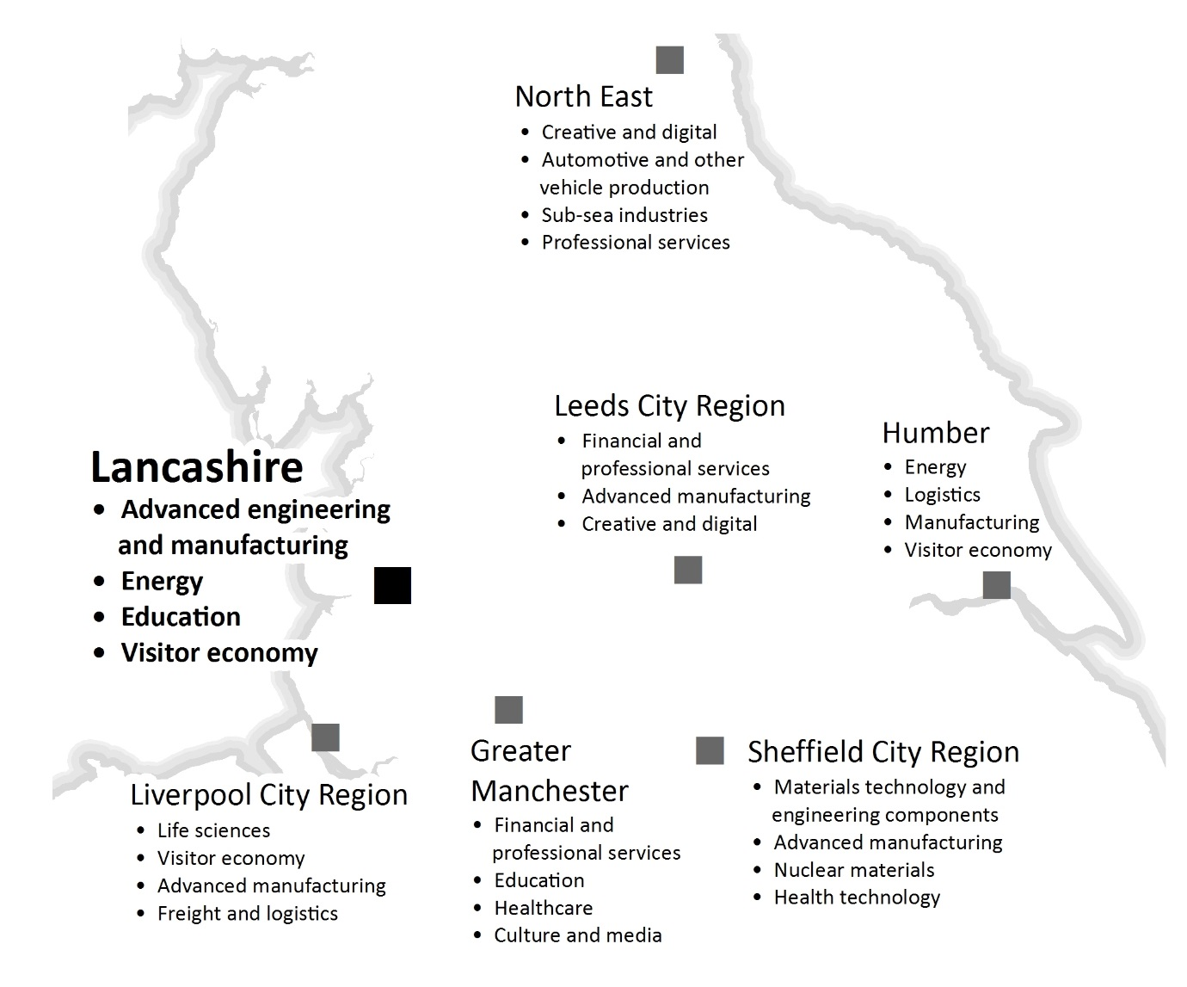
Source: Transport for the North

Growth Deals have allocated funding for economic growth and development across the North, with significant private sector investment planned and underway:

Government Northern Powerhouse investments: | Private Sector investments planned  and underway:
£235 million  Sir Henry Royce Institute for advanced materials research, based in Manchester, with centres in Leeds, Liverpool and Sheffield  £113 million  Cognitive Computing Research Centre in Warrington  £78 million  The Factory Manchester, a new theatre and exhibition space  £20 million  Innovation Hub for Ageing Science in Newcastle  New National  College for Onshore Oil and Gas in Blackpool, with centres at Chester, Redcar and Cleveland  Doubling the number of northern cities to benefit from the Government's superfast broadband programme | Humber  £310 million wind turbine technology from Siemens and Associated British Ports  £450 million Logistics and Marine Energy Park from Able UK  £350 million bio fuel refineries from Vivergo Fuels  Liverpool City Region  £350 million Liverpool2 deep-sea container port from Peel Ports  £920 million City Centre retail from Grosvenor Group  Greater Manchester  £800 million Airport City Enterprise Zone  £1 billion East Manchester housing programme from Abu Dhabi United Group  Lancashire  Advanced Engineering and Manufacturing Enterprise Zone  £100 million Lancaster University Health Innovation Park  £50 million UCLan Engineering Innovation Centre, Preston  North East  £150 million in Newcastle's marine and offshore sector  £82 million train construction facility from Hitachi  Leeds City Region  £150 million Victoria Gate Leeds city centre  £260 million Broadway Bradford city centre  Sheffield City Region  £400 million Peak Resort, Sheffield city centre  £400 million intermodal freight interchange in Doncaster from Veridon
Source: HM Treasury, Transport for the North and publically available sources.

The Lancashire Strategic Economic Plan:
A Growth Deal for the 'Arc of Prosperity'

The overarching purpose of Lancashire's Strategic Economic Plan and Growth Deal is to re-establish Lancashire as an economic powerhouse and a national centre of excellence in advanced manufacturing by maximising its clear competitive strengths and capabilities in the aerospace, automotive, energy and Higher Education research related sectors. This will be achieved by focusing on an 'Arc of Prosperity' that extends across Lancashire and incorporates key sector priorities of national and international significance, key strategic sites, key clusters of high value activity and internationally recognised centres of excellence in research and innovation. The 'Arc' also incorporates key assets and other sectors including quality of life and housing growth offers, a significant tourism and visitor economy, health, digital and food manufacturing. Supporting this sector and asset development programme is a strategic approach to skills development and business support.

As such Lancashire's economic strengths and growth priorities are a key part of, and critical to, the building of the Northern Powerhouse. The Northern Transport Strategy must reflect this in order to deliver an inclusive and sustainable Northern Powerhouse. For Lancashire to maximise its economic potential, it will need to fully exploit its key innovation assets, growth sectors, skills, and transport infrastructure assets. Lancashire is a county of contrasts with a rich quality of life that distinguishes it from neighbouring city regions and makes it an attractive place in which to live, work and invest, with access to a highly skilled workforce, strongly performing schools, colleges and higher education establishments, strategic transport networks and effective broadband connectivity.

Lancashire's 'Arc of Prosperity'

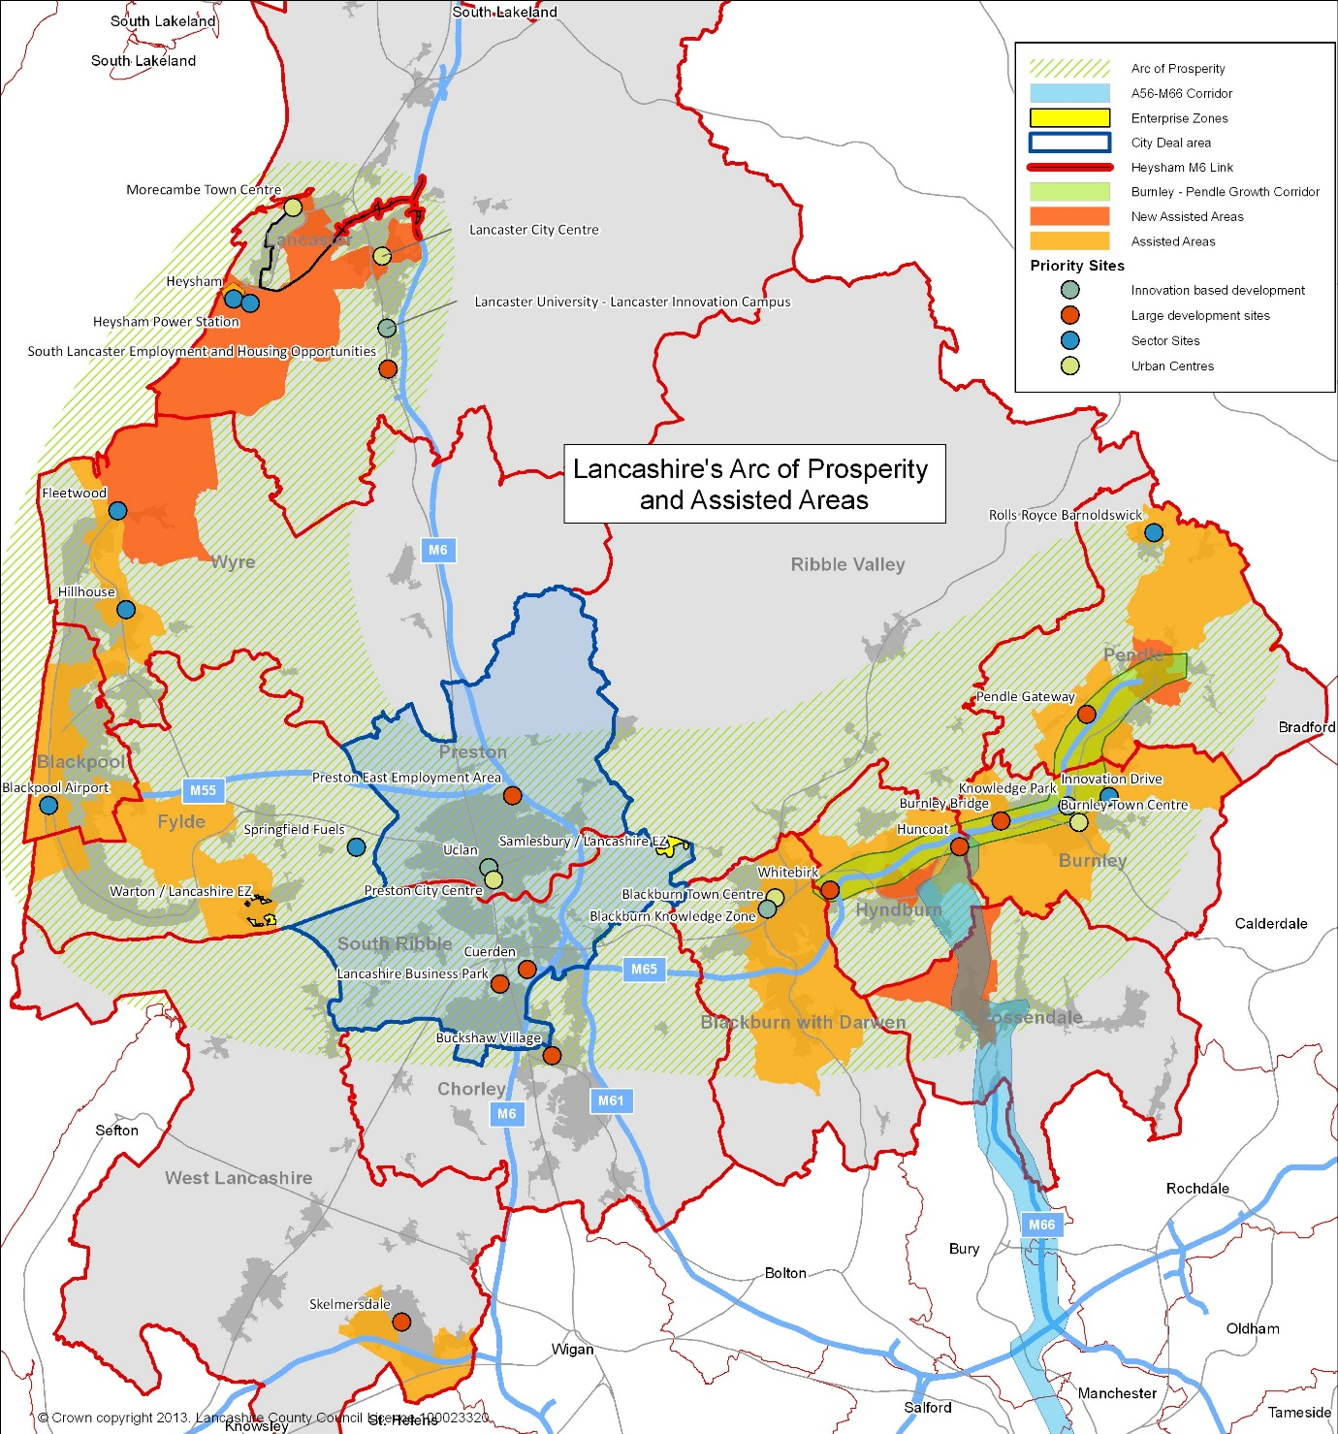

Lancashire's Contribution to the Northern Powerhouse

Valued at over £25 billion, Lancashire has one of the largest economies in the North of England and the second largest in North West England. It is home to over 40,000 businesses employing in excess of 670,000 people, and has a population of 1.4 million. Independent economic analysis has highlighted the presence of business and industrial clusters in growth sectors across and within key locations in Lancashire. These sectors have the potential to deliver a scale of growth that will have a transformative impact on the local economy and contribute significantly to the northern and national economy.

Aerospace

Lancashire is central to a regional cluster of aerospace capability recognised as the fourth largest in the world. One of three key clusters of aerospace capability in the UK, it is the only one in the North of England, contributing £850 million to the national economy. As a result, Lancashire makes a significant contribution to the whole supply chain of this industry. The county hosts the single largest concentration of aerospace production in the UK, employing over 20,000 people. Major employers include BAE Systems, Rolls Royce and Safran-Aircelle. These internationally renowned companies have attracted, and support, strong supply chains in design, testing, manufacturing and repair and maintenance. Lancashire's Enterprise Zone focuses on these sector strengths to provide world class development opportunities. BAE Systems' Lancashire sites are contributing in the region of £6 billion in value to the F35 programme, which is the UK's single largest trade contract.

Automotive

The automotive sector has an important base in Lancashire, with a workforce of over 3,500. Key companies include PACCAR (Leyland Trucks), Piolax, Sanko-Gosei, Erlson, Futaba-Tenneco and TRW Automotive. The supply chain is significant, with the majority of business activity focussed on the supply of high value parts to the UK and European Original Equipment Manufacturers (OEMs), a key Lancashire capability that the UK as a whole is seeking to grow. Exploiting a legacy of testing facilities, Lancashire hosts a significant cluster of innovative design and development companies, including Torotrak, Clean Air Power and Scorpion Automotive.

Energy

Over 37,000 people in Lancashire work in the power generation sector. The sector enjoys strong support from Lancaster University and the University of Central Lancashire, both of whom are internationally recognised centres of excellence in energy and environmental studies. National companies operating in the sector include Springfield Fuels, EDF, AMECPLC, SITA, Assystem and Westinghouse-Toshiba. Westinghouse facilities in Lancashire have nuclear reactor and fuel processing contracted programmes valued in the hundreds of millions of pounds.

The two nuclear power stations at Heysham represent one of the largest concentrations of power generation in the UK. Decommissioning is anticipated to commence at Heysham 1 in 2019, with Heysham 2 following soon after. The close proximity of Lancashire to a number of Nuclear Decommissioning Authority sites makes it an ideal central location from which to serve the industry. Also, the Springfields Fuels site has the capability and capacity to manufacture fuel for all designs of worldwide nuclear reactors.

The specific strengths of Lancashire's nuclear sector, if properly combined with key assets and opportunities in Cumbria, Manchester, Cheshire and Sheffield, creates the prospect of establishing a coherent industrial and skills strategy for the nuclear sector across the North of England. Given these cross boundary issues and in line with the emerging national nuclear strategy; the Lancashire Enterprise Partnership is seeking the development of such an approach under the overarching direction of the Nuclear Advanced Manufacturing Research Centre (NAMRC), which is based in Sheffield.

The Port of Heysham, owned and operated by Peel Ports, which in addition to its Ro-Ro ferry operations is an important UK offshore supply base providing logistics support to one of the largest offshore gas fields in UK waters. The Port is well placed to exploit the market opportunities presented by significant offshore wind operations and maintenance facilities. Peel is exploring new commercial investment opportunities following completion of the Heysham to M6 Link Road.

Lancashire has potentially one of the largest reserves of shale gas in Europe, and although the extent and viability of this reserve is still being examined, significant planning issues remain unresolved. However, the Lancashire Enterprise Partnership is mindful that, subject to regulatory confirmations, the shale gas sector may begin to play an important economic role. Locating an 'elite' institution in Lancashire for shale gas will be important in establishing the sector both locally and nationally.

Higher Education Institutions

Lancashire hosts a significant concentration of Higher Education Institution excellence, including one of the largest concentrations of university assets in the North comprising Lancaster University, the University of Central Lancashire (UCLan) based in Preston and Edge Hill University in Ormskirk. Lancaster is also home to the largest campus of the University of Cumbria.

Lancaster University is a world renowned institution, consistently ranking amongst the top ten UK universities for research and teaching, and is ranked first for physics research. The university has over 11,000 students and its international profile supports the establishment of industrial links with key international markets. UCLan is the 5th largest university in the country in terms of its undergraduate in-take and was the first modern UK University to be ranked in the prestigious QS world rankings. Both are developing new high-technology facilities of national significance: a £100m health innovation park at Lancaster University and a £50m engineering innovation centre at UCLan in Preston.

Delivering Growth through Transport Investment

The Strategic Economic Plan identifies transport connectivity as fundamental to delivering economic growth and potential across Lancashire. However, despite sustained growth in the last decade particularly in identifiable economic 'hotspots' such as the cities of Preston and Lancaster, Lancashire's average performance still consistently lags behind that of the UK and neighbouring city regions. For example, between 2007 and 2011 Lancashire's economy grew by 4.4% compared to 6.5% nationally and 4.9% regionally, meaning Lancashire's GVA per capita was 77% of the UK average. Today the economic performance of Lancashire is more than 20% below the national average in terms of GVA per resident.

Lancashire has benefitted in recent years from key transport and infrastructure investment of national significance such as the West Coast Main Line Route Modernisation programme completed in December 2008. However, apart from the completion of the Heysham to M6 Link Road due to open in summer 2016 and the Pennine Reach public transport scheme in East Lancashire currently being implemented, there has been little investment in critical local strategic infrastructure to improve connectivity and support economic growth, development and regeneration. It is estimated that failure to deliver the transport infrastructure needed to support sustained business success accounts for one quarter of Lancashire's current economic performance gap with the rest of the UK.

To address this key barrier to growth, Lancashire has developed a suite of five Highways and Transport Masterplans covering the entire county. These masterplans have provided the opportunity to align strategic transport investment across all modes with economic development and spatial planning priorities including housing. This approach helped secure the Preston, South Ribble and Lancashire City Deal, agreed with the Government in September 2013, and shaped Lancashire's Strategic Economic Plan and subsequent Growth Deal.

Central Lancashire, with Lancashire's principal city Preston at its heart, is a transport hub of national significance, providing most of the county's connections to the West Coast Main Line, the M6 and, in the future, to HS2. The Preston, South Ribble and Lancashire City Deal builds on the strong economic performance of the area over the last ten years and will see Central Lancashire transformed, creating 20,000 net new private sector jobs and delivering over 17,000 new homes, underpinned by significant investment in new and improved transport infrastructure. Whilst Lancashire's growth sectors will account for many of these jobs, in particular, at the Enterprise Zone sites at Samlesbury and Warton, Preston's business and financial sector will also expand, with the University of Central Lancashire reconfiguring to place itself at the heart of the city. It will be vital to business, whether based in Central Lancashire or further afield, that accessing Lancashire is straightforward and not compromised by problems on the rail and strategic road networks elsewhere across the North.

Lancaster is home to one of the country's top teaching and research institutes, Lancaster University being in the top 1% of global universities. The emphasis on research makes Lancaster a key hub for innovation, and with major expansion proposed at and around the University connectivity for business and academia is of particular importance. The district is also home to the major port of Heysham, a key facility for Irish Sea Ro-Ro traffic between the UK mainland and Ireland and the Isle of Man. Completion of the £130m Heysham to M6 Link Road in the summer of 2016 will significantly improve the port's access to the M6, but for the port to reach its full potential, the Strategic Road Network across the North must be effective.

East Lancashire, centred on Blackburn and Burnley, has a growing portfolio of higher value industries with aerospace, advanced manufacturing, advanced flexible materials, digital and creative industries all featuring strongly in the area's economy, making it key to both the success of the Lancashire Enterprise Zone and to the Arc of Prosperity. With easy access to high quality rural areas including the Forest of Bowland Area of Outstanding Natural Beauty, East Lancashire also has the potential to become a sought after place of residence for commuters. However, the quality of many local rail services and infrastructure leaves much to be desired, hence there is a significant identified requirement for greatly enhanced rail connectivity, with higher speeds, greater frequency and better rolling stock quality to enable East Lancashire to link into and support both Lancashire's growth and that of neighbouring city regions such as Manchester and Leeds. East Lancashire's motorway gateways are also pivotal in supporting our ambitions, again both for Lancashire as a whole and for its role in the wider economy of the North.

The Fylde Coast is one of the more affluent areas in Lancashire, containing towns and rural areas popular with commuters, with the advanced engineering and manufacturing sector providing highly paid jobs that underpin local economies. With the nationally significant resort of Blackpool central to the area and a visitor economy that is revitalising supported by recent investment, leisure and tourism are important components of the Lancashire economy. In March 2015, Lancashire's Enterprise Zone extended to include Blackpool Airport.

Despite its fundamentally rural nature, West Lancashire is home to a number of international and nationally recognised companies and Edge Hill University. Located between the major growth areas of Manchester, Liverpool and Central Lancashire, the area provides the perfect location for logistics and distribution companies, with Skelmersdale particularly well-placed to take advantage of the opportunities presented by the development of the Liverpool SuperPort concept, a key priority for the Liverpool City Region Economic Plan. The Atlantic Gateway initiative, a collection of assets including transport infrastructure that represents an opportunity for growth, lies just to the south.

The masterplans have identified the strategic and local transport priorities to improve connectivity and support economic growth, development and regeneration. Our national and local strategic priorities are set out in the following sections of this prospectus. Further work is being undertaken to identify the Gross Value Added (GVA) uplift addressing these priorities will deliver. It will also highlight the potential for Lancashire's GVA gap to widen further without such investment.

The Northern Transport Strategy:
Lancashire's National Strategic Priorities

The following national strategic priorities are integral to the long term transport strategy for the North and will ensure that Lancashire, as one of the North's most significant sub-national economies, continues to prosper and support the vision and objectives of the Northern Powerhouse.

HS2 and the West Coast Main Line

Preston lies approximately mid-way between Glasgow and London on the West Coast Main Line, and also has regular direct services to Manchester, Manchester Airport, Birmingham, Edinburgh, Leeds and Liverpool, as well as providing connections into these services from Blackpool, Blackburn and East Lancashire, Lancaster and the Lake District. The railway station is therefore a critical asset for the city and for Lancashire and also serves as a gateway for communities further afield, particularly for connectivity to the West Coast Main Line. With over 4.5 million passenger users annually and a further 1.3 million interchanges, Preston is the busiest station in the North West outwith Manchester and Liverpool city centres and one of the busiest in the North.

As a key economic centre in its own right and identified by Government as such, it is vital that Preston has direct and frequent access to HS2 and any potential HS3 in fit for purpose surroundings. However, the station fabric has seen little investment in recent years resulting in a poor passenger experience and preventing the station from contributing towards the wider commercial development of the city centre. The station needs transforming into a modern, 21st Century facility from which, to which and through which passengers can pass in comfortable surroundings, one that will encourage greater rail use and fully maximise the inherent advantages of Preston's location on the rail network. Such a transformation will also help to enhance the station's presence within the city centre and its relationship to existing and proposed business district development.

The significance of Preston Station as a driver of economic growth is recognised by stakeholders both within and outside Lancashire. As such, the station's development is of fundamental importance to the economic growth aspirations across Lancashire, and in so doing, particularly once HS2 becomes operational, will reinforce Preston's role as the North West's major rail hub north of Manchester. Establishing an HS2 Growth Strategy as recommended by the HS2 Growth Taskforce for Preston will be an important element to achieving this. In addition, Network Rail has requested the City and County Councils prepare a long term vision for the station to inform its strategic review of West Coast Main Line capacity north of Crewe. The County Council has recently commissioned Mott Macdonald to prepare an outline masterplan for Preston station.

From a Lancashire perspective, whilst the recommendation from Sir David Higgins to accelerate delivery of an HS2 Hub at Crewe in 2027 rather than 2033 as originally planned is welcomed, it is essential that a connection from HS2 to the West Coast Main Line further north is retained. The recommendation to review this connection in light of concerns raised through consultation is noted, as is Sir David's assertion that such a link will be necessary sooner rather than later as part of the wider consideration of how to improve services to Scotland. Lancashire also wishes to see this link considered in conjunction with the proposed wider examination of east-west connectivity across the North including HS3, the proposed new Trans-Pennine rail connection linking Manchester with Leeds and Sheffield.

The M6 Motorway

The M6 is an integral part of the UK’s main north-south transport spine between London, the West Midlands and Scotland, which also includes the West Coast Main Line. From a Lancashire perspective, it is particularly important for the movement of freight, for example, to and from the Port of Heysham, and for logistics and distribution companies located in Central Lancashire and Skelmersdale. South of Preston, deterioration in the operational effectiveness of the route is resulting in increased average journey times and a worsening of journey time reliability. This is likely to have a damaging effect on freight operations, many of which function on the basis of ‘Just in Time’ delivery. Lancashire therefore welcomes the commitment in the Road Investment Strategy to upgrade much of the M6 south of Junction 26 (the M58 west of Wigan) to Smart Motorway by 2019/20.

Even with full delivery of the schemes set out in the Central Lancashire Highways and Transport Masterplan, evidence suggests that the M6 Preston Bypass will be under pressure by 2026, particularly during peak periods between Junctions 30 and 32 with the M61 and M55 respectively. This length of the M6 already has four lanes in each direction, so at some stage the potential to introduce 'Smart Motorway' technology will need assessing. Possible scheme elements could include access controls at junctions and variable speed limits. For consistency, Lancashire therefore wishes to see the 'smart spine' linking the North West and London referred to in the Road Investment Strategy ultimately extend as far north as Junction 32.

The Preston to Manchester Rail Corridor and M61 Motorway

The rail corridor linking Preston with Manchester city centre and Manchester Airport is not only of strategic importance to much of Lancashire but also to Cumbria and Scotland. Stations in central Manchester provide connections for onward travel to and from a range of other key destinations across the North, including Leeds and Sheffield. The transport strategy for the North therefore needs to reflect this. In addition, recent economic and employment growth in Lancashire has been strongest in this corridor, with parts of Central Lancashire in particular seeing strong employment growth. It is also the corridor with the greatest opportunity to grow the business travel market in Lancashire and in tandem to help reduce congestion on the parallel M61.

The Northern Hub, due for completion in 2018, will address capacity and network constraints on the rail network in and around Manchester and, when considered alongside completion of electrification between Manchester / Liverpool and Preston / Blackpool North by December 2016, will deliver a significant improvement in terms of connectivity and capacity in the key corridors linking parts of Lancashire with Manchester and Liverpool city centres and Manchester Airport.

Modern electric trains have already been introduced on Trans-Pennine Express services between Scotland and Manchester Airport, which currently travel via Wigan North Western. However, although there are on average four trains per hour between Preston and Manchester (three serving Piccadilly and one Victoria) throughout the working day there is significant overcrowding, particularly on services linking Scotland / Cumbria / Blackpool North with Manchester Piccadilly and Manchester Airport. In January 2015, the Government announced more diesel powered carriages for selected services in the corridor, but these are of a much lower quality than the rolling stock currently operating Trans-Pennine Express services between Blackpool North and Manchester Airport.

Travel times for the journey between Preston and Central Manchester currently range from 40 minutes by the fastest trains to 56 minutes by the slowest; electrification will see the line speed raised up to 100 mph in places and the quickest journey times reduced to nearer 30 minutes as a consequence. However, it will be essential to ensure that the advantages electrification will deliver in terms of improved quality of service are not eroded through failure to provide sufficient capacity both in terms of length of train and service frequency.

The M61 links the M6 at Preston with the M60 Manchester Outer Ring Road and the Trans-Pennine M62. Although existing traffic flows are generally within the capacity of the road, the M61 Corridor is heavily used by commuters, and significant congestion with long queues of standing traffic occurs during the morning peak period on the southbound approach to the M60 at Junction 15 as traffic attempts to access Manchester City Centre via the A580 and other destinations via the M60.

Lancashire therefore has a strategic interest in the operational effectiveness of the M60 as this provides access to and from Manchester Airport via the M56 and Yorkshire and eastern England via the M62. Consequently, the Manchester North West Quadrant Study announced in the Department for Transport's Road Investment Strategy is of particular interest to Lancashire.

Lancashire's Local Strategic Priorities (1):
Connecting Lancashire to City Region Networks

The Northern Transport Strategy is not just about travel between city regions. It also includes the development of city region rail networks that provide the additional capacity required to sustain city centre growth. These networks will interconnect with HS2, new intercity services across the North and metro/tram systems, supported by much expanded park and ride facilities. They will require electrification, new rolling stock (a matter of urgency for the North in terms of quality and sufficiency), higher service frequencies, new services and the removal of network pinch points. Development of European style cross city region networks centred on hub stations is a key aspiration.

East Lancashire

In East Lancashire, a number of improvements to the rail network have either been delivered or are programmed, including the recently completed upgrade to Burnley Manchester Road station and the introduction of a new direct train service between Blackburn, Accrington, Rose Grove, Burnley and Manchester Victoria via Todmorden and Rochdale from May 2015. Lancashire County Council and Blackburn with Darwen Borough Council are also working with Network Rail to deliver a scheme to improve the reliability and frequency of rail services on the route between Clitheroe, Blackburn and Manchester Victoria. This is now a funded scheme within the Lancashire Enterprise Partnership's transport investment programme due for delivery in 2015/16. It will facilitate provision of an all-day, half hourly service between Blackburn and Manchester to be delivered through the new Northern franchise. Currently, a firm date for the commencement of the additional off-peak services has not been finalised, but it will be no later than December 2017 utilising rolling stock made available through the North West electrification programme.

Whilst the above developments will bring about some improvement to the rail network in East Lancashire, they will not address the fundamental issue of whether or how the rail network can contribute towards a transformational change in East Lancashire's economic fortunes. East Lancashire is perceived as an area that is poorly connected with a transport network that hinders the efficient movement of both people and goods, and that this relative isolation has a negative impact on economic development and impedes regeneration. The East Lancashire Rail Connectivity Study has examined this issue in depth, in particular, the importance of enhanced connectivity between East Lancashire and the growth centres of Preston and Central Lancashire, Manchester including Manchester Airport, and Leeds.

The Connectivity Study has identified a number of deficiencies with the current network, including:

- Slow journey times, especially on the 'Copy Pit' line between Burnley and Todmorden used by the train service between East Lancashire and Leeds and from May 2015, the new service between East Lancashire and Manchester Victoria via Rochdale;
- Poor reliability due to long, single-track sections, for example, between Burnley and Colne;
- Capacity constraints, with longer trains required to meet growing demand, in particular, on commuter services between Clitheroe and Manchester;
- Low service frequencies;
- Poor quality rolling stock; and
- A lack of facilities at many of the smaller stations, which will need to meet as a minimum the Station Quality Standards set out by Rail North.

All of the above make rail a less attractive mode of travel; consequently, use of the rail network in East Lancashire is relatively low compared to neighbouring areas, including between East Lancashire and neighbouring city regions.

The Connectivity study has concluded that significant investment will be necessary in order to improve both the performance and attractiveness of East Lancashire's rail network, and that without such investment, the perception of East Lancashire as being poorly connected is likely to grow. Moreover, current and proposed investment in the rail network elsewhere across the North of England has the potential to widen the connectivity 'gap' between East Lancashire and key economic centres such as Manchester and Leeds. Failure to improve or replace existing rolling stock is likely to lead to further deterioration on the quality of the trains, potentially impacting on journey quality, capacity and performance. This could result in existing rail passengers seeking to use alternative modes of transport, placing additional pressure on an increasingly congested highway network.

The Rail Connectivity Study adopted a Conditional Outputs approach in accordance with standard rail industry practice, recognising that to deliver transformational change to East Lancashire's rail network will require as a minimum the support of Network Rail, Rail North and the relevant Train Operating Companies. Whilst the realisation of each output will be subject to the identification of an affordable and value for money solution, the study concluded that electrification of the routes between Preston and Leeds / Colne and Clitheroe / Blackburn and Bolton together with associated rolling stock improvements would make the most significant contribution. Inclusion of the full 'Calder Valley', which includes the route between Preston and Burnley, and the Bolton to Clitheroe route as Tier One schemes in the report of the North of England Electrification Task Force with a recommendation for implementation in Control Period 6 (2019 to 2024) is therefore a most welcome development.

Skelmersdale

Whilst Skelmersdale enjoys excellent strategic connectivity to the Strategic Road Network via the M58, the local transport network is no longer capable of supporting current economic growth aspirations, with a road network that is not fit for purpose, inadequate public transport provision, lack of provision for pedestrians and cyclists and an inhospitable public realm. Access to both Liverpool and Manchester is limited; the nearest railway station, Upholland, is not easily accessible without a car and only served by an hourly train service to Kirkby and Wigan, and bus services are slow and journeys indirect.

The West Lancashire Highways and Transport Masterplan, adopted by Lancashire County Council in October 2014, is proposing the wholesale reconfiguration of Skelmersdale's transport networks to meet both current and future needs, not just for local residents and businesses but for West Lancashire as a whole. This is a transformational proposal and a once in a generation opportunity to reshape Skelmersdale through a single programme of works spread over a number of years to ensure that the town has a sustainable, integrated transport network that will allow it to grow and prosper in the future. At its heart is a new rail link and town centre railway station, fully integrated with the bus network and easily accessible on foot or by cycle, and with sufficient car parking provision to function as a 'Parkway' station for the wider West Lancashire area.

Skelmersdale would be served by a new spur from the existing Wigan Wallgate to Kirkby line into the town centre, enabling through services to operate to both Liverpool (via Kirkby) and Manchester (via Wigan), providing direct access to growth opportunities in both city centres and potentially at Manchester Airport and the Airport City Enterprise Zone. The Atlantic Gateway initiative, a collection of assets including transport infrastructure that represents an opportunity for growth, lies just to the south of the town. Furthermore, the new station and interchange is intended to act as a catalyst for the wider redevelopment and growth of the town centre. The Skelmersdale Rail Link features in the Lancashire Enterprise Partnership's Strategic Economic Plan submitted to the Government in March 2014 and the Liverpool City Region Long Term Rail Strategy published in August 2014.

Lancashire County Council and its partners Merseytravel and West Lancashire Borough Council commissioned Network Rail to undertake a GRIP Stages 1-2 (Guide to Rail Investment Process - output definition / feasibility) study to develop the proposal set out in the masterplan, including indicative costs. Merseytravel also has a long-standing aspiration to open a station at Headbolt Lane in Kirkby, which would impact on the project. This work has now concluded. The County Council separately commissioned Jacobs UK limited to undertake an assessment of the likely value for money and wider economic benefits of the proposal commensurate with a Strategic Outline Business Case and the Assurance Framework of the Lancashire Enterprise Partnership.

Work undertaken to date has demonstrated that it is technically feasible to construct a heavy rail link into Skelmersdale town centre in the corridor identified in the West Lancashire Highways and Transport Masterplan, and that the project could deliver value for money. It is therefore a viable proposal. The County Council and partners anticipate that a scheme could be delivered during the next rail industry investment period covering 2019 to 2024 (known as 'Control Period 6'), although informal discussions with the Department for Transport suggest it would most likely need financing through the Local Growth Fund. The next stage in the project development process is GRIP Stage 3 (option selection) the main output being determination of a single option and securing stakeholder approval.

West Lancashire

Merseyrail currently operates a fast and frequent service between Liverpool and Ormskirk using electric trains. However, onward travel to Preston requires a change of train to a diesel-operated service that is infrequent and run to an irregular timetable. Rolling stock quality is also poor. Electrification of the Ormskirk to Preston route with appropriate infrastructure enhancements would resolve the majority of issues, significantly improving connectivity between Preston, West Lancashire and the Liverpool city region. In addition, there is the potential to provide better interchange between Liverpool-Ormskirk-Preston and Manchester-Wigan-Southport services at Burscough. Both are aspirations in the Liverpool City Region Long Term Rail Strategy published in August 2014.

Morecambe

Electrification of the short length of route between the West Coast Main Line north of Lancaster and Morecambe could significantly enhance the town's connectivity thereby allowing the resort to benefit from the ongoing electrification programme across the North West. Work to be undertaken shortly will establish whether there is a business case for such an enhancement.

Lancashire's Local Strategic Priorities (2):
Supporting Economic Growth, Development and Regeneration

New Ribble Crossing

The Central Lancashire Highways and Transport Masterplan included a longer term (post 2026) proposal to construct a new crossing of the River Ribble to link together the Preston Western Distributor and the South Ribble Western Distributor via a completed Penwortham Bypass to provide a continuous dual carriageway route between Cuerden and the M55 to the west of Preston. Delivery of these schemes has been accelerated through the Preston, South Ribble and Lancashire City Deal; therefore, the County Council and partners have begun to investigate whether a new crossing could progress more quickly and how such a project might be funded.

M65 East Lancashire Gateway

The M65 plays an essential role in the economy of East Lancashire, connecting people and businesses internally as well as providing the primary means of access to Central Lancashire and the M6, particularly for freight. Unlike most motorways, the M65 is not three lanes throughout its length, with reduced capacity on some sections, particularly between the M61 and Junction 6 at Whitebirk. Traffic has grown consistently by around 4% per annum since the motorway's completion in 1997, and evidence now suggests that the current level of demand at peak times is causing congestion, with some junctions at or near capacity.

The predominantly two lane section between the M61 and Whitebirk is increasingly likely to become a bottleneck, reducing the ability of the M65 to function as a major gateway to East Lancashire. Through the East Lancashire Connectivity Study, Lancashire County Council and partners are investigating whether and when additional capacity on the M65 between the M61 and Whitebirk might become necessary and how it might be provided. This work is expected to conclude by autumn 2015.

M66 East Lancashire Gateway

As part of the East Lancashire Connectivity Study, Lancashire County Council and partners are undertaking a study to examine the importance of enhanced connectivity in the M66 corridor to Rossendale and the rest of East Lancashire and to identify how best to achieve this enhanced connectivity if there is demonstrable evidence that investment will deliver significant wider economic benefits for East Lancashire and Rossendale in particular.

The study scope includes the Strategic Road Network and relevant routes into Manchester city centre, the 'Metrolink' line between Bury and Manchester Victoria and the national rail network between Rochdale and Manchester Victoria. The study is also considering what form a commuter rail link between Rawtenstall and Manchester could take, as there are a number of potential solutions to rail provision in the corridor.

Given the concern locally that congestion in the M66 corridor is now acting as a constraint on economic growth and social opportunities, the study is also assessing the wider economic, social and distributional benefits and Gross Value Added uplift of any potential transport investment. The study is expected to conclude in summer 2015.

Blackpool North Interchange

Blackpool's new central business district development (Talbot Gateway) is located adjacent to Blackpool North station, the new offices opening up opportunities for commuting by rail. Blackpool North is also the key gateway to the resort for longer distance travellers, but for such a major arrival point, the actual experience on offer is not good.

The Tramway is to be extended from the Promenade to the station, significantly improving public transport connectivity for both residents and visitors. Seamless interchange between the rail network and the tram system will be achieved, providing rail-borne access between the railway station with its newly electrified trains and the Fylde Coast’s tourist attractions and hotels. It is therefore essential that a high quality, multi-modal transport interchange be established at this vital location in support of wider interventions set out in the Lancashire Growth Plan for the renewal of Blackpool.

A585 Corridor

The A585 between the M55 and Fleetwood is currently part of the Strategic Road Network and therefore managed and maintained by Highways England. Its strategic role as part of an inter-regional route between Great Britain and Northern Ireland ceased with the withdrawal of the Ro-Ro ferry service from the Port of Fleetwood to Larne in December 2010. The A585 nevertheless remains a key route within the Fylde Coast highway network and is vital to the regeneration of Fleetwood and the success of the Hillhouse International Business Park at Thornton.

As part of its Pinch Point Programme, in 2014/15 Highways England completed significant improvements at the A585/A586 'Windy Harbour' junction near Singleton and the A585 junctions with Bourne Way and West Drive between Thornton and Cleveleys at a combined cost of £3.1m. Congestion nevertheless remains an issue at a number of other locations, in particular, the Five Lane Ends traffic signals at Little Singleton, which is arguably the worst remaining bottleneck on the on the route and a difficult location at which to make a significant improvement. The Department for Transport's Roads Investment Strategy includes a commitment to deliver a new, off-line bypass of Little Singleton to reduce the impact of traffic on the local community and remove the bottleneck.

The A585 needs to operate as effectively as possible along its entire length. The County Council will therefore work with Highways England to identify a programme of cost effective, viable improvements to remove any remaining pinch-points on the route, in particular, along the unimproved length between the M55 and the Windy Harbour junction.

South Fylde Line

The consultation draft Fylde Coast Highways and Transport Masterplan identifies the South Fylde Line (Blackpool South to Kirkham and Preston via Lytham St Annes) as a key weakness in the Fylde Coast public transport network. The potential of the line could increase significantly if possible connections with the Blackpool Tramway are considered. Lancashire County Council has recently become a partner in the European SINTROPHER (Sustainable Integrated Tram-based Transport Options for Peripheral European Regions) project. The Council has secured funding to investigate the best way of enhancing the role of the South Fylde Line in providing a southern gateway to Blackpool and to establish what the most viable and cost-effective way of linking the South Fylde Line and the Blackpool Tramway might be and what benefits such a link might deliver. The study is due to report by June 2015.

Lancaster South

The area immediately to the south of Lancaster has been identified as one capable of delivering significant development, critical to meeting the future housing and employment growth needs of Lancaster and which will deliver wider economic benefits to Lancashire and beyond. It lies adjacent to Lancaster University and includes planned major housing sites at Bailrigg and Whinney Carr as well as the site of the proposed Health Innovation Park, an agreed priority in the Lancashire Growth Deal. Jointly these sites are capable of delivering up to 2,000 houses, circa 40,000m² of business and innovation space accommodating over 4,000 high-value jobs and circa 5,000m² of retail and leisure space.

Releasing the development potential of south Lancaster, including the Health Innovation Park, is severely constrained by the existing highway network, with the main access route (the A6) already operating close to capacity. A comprehensive transport solution is therefore required, including strategic and local highway improvements. This could include a reconfiguration of M6 Junction 33 to support both the Lancaster South developments and implementation of a City Centre Movement Strategy post completion of the Heysham to M6 Link Road. Key objectives for the Movement Strategy are to secure an attractive, healthy and safe local environment that contributes to the economic and social wellbeing of the city, its residents and visitors, and to reduce the environmental and social impacts of traffic to the benefit of pedestrians and cyclists and make city centre attractions more identifiable.

BROAD TIMESCALES FOR DELIVERY

By 2021

- Preston, South Ribble and Lancashire City Deal Highway Improvements*
- Preston to Manchester Rail Corridor Improvements to provide additional capacity and better quality rolling stock
- Blackburn to Bolton Rail Corridor Improvements to provide additional capacity*
- Blackpool Tramway Extension North Pier to Blackpool North Station*
- Blackpool North Interchange (Talbot Gateway)
- A585 Corridor Improvements, including a bypass of Little Singleton*

By 2026

- Preston Railway Station / HS2 Interchange
- New Ribble Crossing
- East Lancashire Rail Network Transformation, including electrification and better quality rolling stock
- M65/M66 East Lancashire Gateway Improvements
- Skelmersdale Rail Link and Town Centre Transport Interchange
- Lancaster South Supporting Infrastructure
- Lancaster to Morecambe Rail Electrification

By 2031

- 'Smart Motorway' technology extended northwards along the M6 to Junction 32
- Ormskirk to Preston Rail Electrification
- South Fylde Line Enhancements

*Funding commitment

Speech delivered by the Rt Hon George Osborne MP at the Museum of Science and Industry in Manchester, 23rd June 2014
HS2 Plus, A report by Sir David Higgins, Chair of HS2, March 2014
One North – A Proposition for an Interconnected North, (Greater Manchester, Merseyside, South Yorkshire, West Yorkshire and Tyne & Wear) July 2014
Lancashire Strategic Economic Plan: A Growth Deal for the Arc of Prosperity, Lancashire Enterprise Partnership, March 2014
Strategic Commercial Development Advice, Colliers, 2014. This advises that defining what a cluster constitutes is not an exact science but there are indictors which can give an idea as to whether a cluster is present; these include the geography of where companies are based and their proximity to one another, the number of companies based in a certain geographic area and the size and levels of employment of companies.
Economic Forecasts for Lancashire, Oxford Economics, 2013
Lancashire Strategic Economic Plan: A Growth Deal for the 'Arc of Prosperity', Lancashire Enterprise Partnership, March 2014
High Speed 2: Get Ready, A report to the Government by the HS2 Growth Taskforce, March 2014
Rebalancing Britain; From HS2 towards a national transport strategy, October 2014
Road Investment Strategy, Department for Transport, December 2014
It is currently almost as quick to travel from Preston to Leeds by changing trains in Manchester as it is to use the direct service via Burnley and Bradford.
East Lancashire Rail Connectivity Study Stage 3: Conditional Output Statement, Jacobs UK Ltd for Lancashire County Council, April 2015
Northern Sparks, Report of the North of England Electrification Task Force, March 2015
Skelmersdale Rail Link Business Case Study Final Report, Jacobs UK Ltd for Lancashire County Council, January 2015

